

CS 3500 – Software Engineering  
Project #1 – Requirements (Use Case Model)

Kefin Sajan and Jesus Toxtle

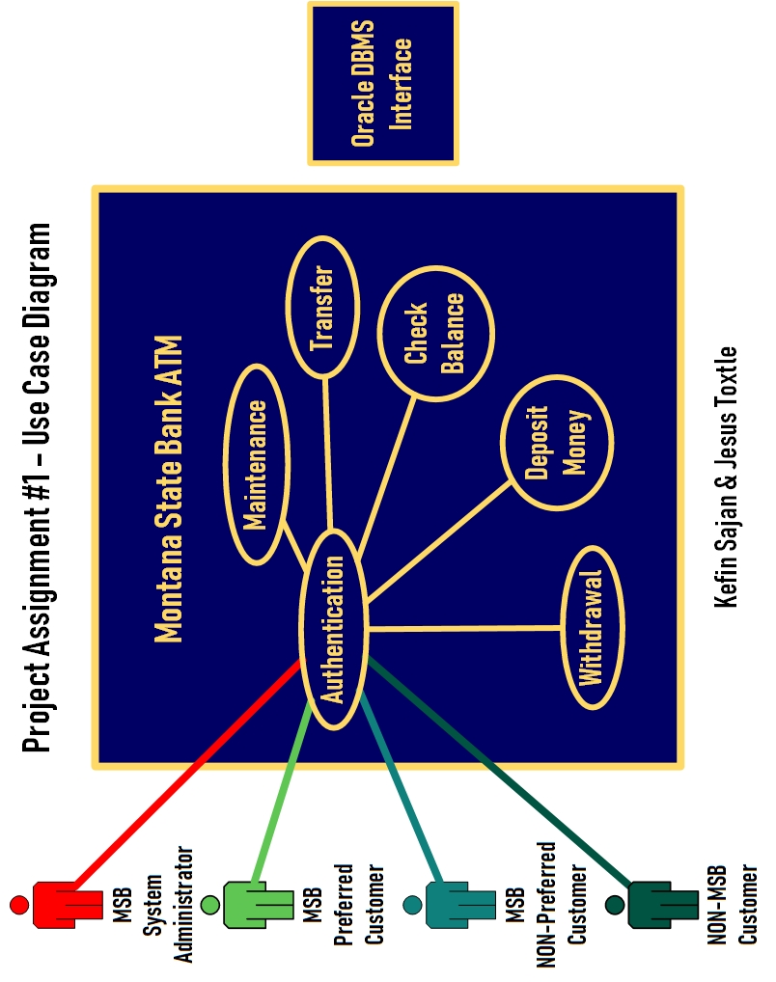

Authentication – Use Case Description  
Name: Authentication  
Author: Kefin Sajan and Jesus Toxtle  
Last Update: 10/23/2019  
Pre-Conditions:

* The user (preferred MSB customer, non-preferred MSB customer, non-MSB customer, and MSB system administrator already has their own ATM card).

Dialog:

* The user begins the authentication process by inserting their card into the ATM. Enter PIN screen immediately appears.
* For the non-MSB customer: they can use a different bank card, enter their PIN, but the Oracle Database will return a message explaining that they’re not MSB customers. Also, they will be faced with a term of services and agreement detailing that MSB will hold a $3 service fee for any withdrawals for a day.
* As for the MSB system administrator: they have a unique ATM card that is not like the others, and by inserting it, they will bypass all standard protocol and can begin to perform maintenance. They also have their MSB issued debit cards for any regular transactions.
* After the user has entered their PIN, a successful login screen will appear, followed by a welcome back screen, and will be shown with the home screen listing all types of transactions allowed on the ATM depending on the Actor.
* If it is the system Administrator, the ATM will present itself to a screen allowing Admin to emulate as a regular ATM user to test functions of ATM. Otherwise, the Admin can select maintenance mode, which is a unique screen visible to only system Administrators.
* However, should the user failed to input their PIN three times successfully, they will be faced with an “ERROR! Unfortunately, we couldn’t verify your identification with us today”. The Oracle Database will record this incident and immediately notify the bank about this warning. “Please take your card back and try again later or at another MSB ATM!” The ATM will also eject the card at that moment.
* Actor after successfully logging in can also immediately log out. Should an Actor decide that they don’t want to proceed with any transaction, they can simply select cancel, and ATM will promptly return the Actor’s card. The Actor must take the card back for the ATM to close its drawer.

Post-Conditions:

* Once ATM detects that ATM card has been taken back, the ATM will close its drawer and a message appears saying, “Thank you! Please come again!”
* Once the user is done with their financial transaction, the user will be faced with a screen that says, “Would you like to do another transaction?”
* Should the user choose yes, the user will go back to the main menu with an array of options?
* However, should the user select No; a screen will appear that says, “Please take your card back!” and ejects the card. Once the user has taken out their card, the ATM machine will proceed by logging out of the user’s account and the user can successfully verify that they were logged out by hearing a ding! Followed by a message, “Thank you for conducting business with Montana State Bank! Please come again!”

Maintenance – Use Case Description   
Name: Maintenance  
Author: Kefin Sajan and Jesus Toxtle  
Last Update: 10/23/2019  
Pre-Conditions:

* For the maintenance screen to appear, the MSB System administrator would already have to successfully authenticate their identity by inserting their own ATM card.
* The maintenance can only be performed by one of the users which is the MSB system administrator.
* The system administrator would already have a specialized ATM card that grants him access to the internal software components of the machine and allowing to proceed with new updates or physical repairs.

Dialog:

* System Administrator will begin the maintenance process.
* Sys Admin will also have access to the internal framework behind the ATM and during the repair process will be completely unusable to anyone else except the sys admin himself.
* There will also appear a message on the ATM screen before Sys Admin begins any physical repairs that says, “ATM Machine is currently under maintenance, please enter the branch to proceed with any and all transactions or try again later!”
* System Administrator begins to either install new software update or open the ATM machine and begin fixing the internal hardware.
* The actor (MSB preferred customer, MSB non-preferred customer, and non-MSB customer) can come back at another time when the maintenance is finished.
* A System Administrator can disable all connectivity activities and monitor each communication to outside of the ATM machine.
* An option for diagnosis log is available to Admin actor, showing time stamps as well as various diagnosis information. The logs can be filtered for error. If a specific error is selected, all communications, user account number and what transaction was performed is available to admin for diagnosis.
* If machine is in maintenance mode, Admin can leave the machine in maintenance mode, shutdown or clear error(s).

Post-Conditions:

* System Administrator will begin to close the ATM machine and after successfully performing maintenance, the administrator will verify by testing out the ATM machine.
* Administrator will run some commands and check that the newly install firmware patch has been downloaded.
* Admin can also insert their own MSB issued debit card and check that any transactions such as depositing money, withdrawals, checking balance, and transferring between accounts can be done with no issue.
* After that, the admin will remove their card, verify that they successfully logged out, and can leave the ATM.
* Maintenance is done and now customers can feel free to use it for any transactions.

Deposit – Use Case Description  
Name: Deposit  
Author: Kefin Sajan and Jesus Toxtle  
Last Update: 10/23/2019  
Pre-Conditions:

* The user (MSB preferred customer, MSB non-preferred customer, Non-MSB customer) has some form of deposit readily available to proceed with their financial transaction.
* Deposits can consist of cash, checks, or both.
* Machine must have all maintenance up to standards and machine must be fully functional to all available user functionalities.
* User must be fully Authenticated, and warnings shown as necessary if user is categorized as “Non MSB Customer”.

Dialog:

* One of the many options is to deposit money. After selecting the deposit money button, the user is presented with another screen. A screen will appear asking to which account they would like to deposit money into, which can range from checking, savings, or money market accounts.
* After selecting the account, it will revert to the previous screen with three options allowing the user to select how they would like to deposit money. A message will also appear underneath these three options, stating that “No coin deposits allowed.
* User must select from, “Cash,” “Checks,” “Both.” Once the Actor has selected one from all three, the transaction will begin.
* If the Actor decides to not proceed with the deposit anymore, the Actor can also select cancel. The Actor will have a screen appear that says, “Would you like to perform another transaction?” If the Actor selects yes, they will be at the main menu with an array of options. If Actor selects no, ATM will say, “Take your card back”. The user must take the card back. ATM will continue to display this message and play a bell-like sound until it detects that the card has successfully been removed.
* If cash is selected, then the ATM will open right underneath the keypad with a repeating bell-like sound. A message will appear along with the sound stating to “please insert up to 50 bills”. The sound will continue until the user has finished depositing all their cash into the machine. A screen will appear asking for confirmation if the amount inserted by the user is correct and displays on the screen. Then, a screen will appear asking if the user would like a printed receipt, emailed, or none. If the Actor selects paper, a paper receipt will print after the transaction has been completed with the available balance, current balance, or money market account balance. If email is chosen, the screen will appear with the Actor’s email and verify if it’s correct. Once the Actor has confirmed the right email an emailed receipt will be sent with available balance, current balance, etc. The drawer will then close, ask the user if they would like to perform another transaction. If the Actor selects yes, then it will ask the user to take their card back and finish processing the transaction. Finally, it will go back to the main menu and give the user an array of options to choose from. If the Actor selects no, the screen will ask the user to “please take you card back!” and finish processing the transaction. Actor will know that the transaction is finished once the screen displays a checkmark and a statement saying, “Thank you for conducting business with Montana State Bank!”
* If check is selected, a screen will appear with the following message, “Ensure all information on the check is correct, and signature is on the back where it’s required.” The ATM will ask for confirmation if the inserted amount is correct. After that, the user can then proceed to insert their check, and a screen will appear asking how they would like their receipt printed out. Whether it be on paper, email, or none. If the Actor selects paper, a receipt will be printed out with the available balance and the current balance on the account, whether it’s checking, savings, or money market account. If email is selected, a receipt will be sent to the customer’s email account with available balance, current balance, or money market account balance.
* If both are selected, two screens will appear that will ask the user to insert their cash and insert their checks too. Once both forms have been inserted, a third screen will appear for confirmation that the deposited amount is correct. If the user selects yes, a screen will appear asking if the user how they like their receipt would. There are three options, paper, email, or none.
* If paper is selected, then a paper receipt will be printed out, and the Actor will take the receipt displaying available balance, current balance, or money market account balance. Actors will be asked if they would like to perform another transaction. If not, then a message will appear to the user saying, “take your card back!”, and the transaction is processing. After that, the user will know the transaction was processed with a sound and a thank you message from MSB for conducting their financial transaction today.
* If email is chosen, machine will display the current email, and if it’s correct, then a receipt will be sent to that email. If that email is not correct, then the user will be presented with a screen asking if they would like to input another email. Once the email has been inputted, the customer will confirm, and the transaction will begin. An email receipt with available balance, current balance, or money market account balance. Another screen will appear, asking if they want to do another transaction. If not, then the user will be prompted to “take you card back!” ATM will play a noise and display a “Thank you message for conducting business with MSB today!”
* An ‘X’ will appear if any problems occurred during the transaction and record all diagnosis data labeled with the timestamp for easy troubleshooting and diagnosis for System Administrator. The actor is given an easy to understand short message if problem is related to their account.
* If any critical error is triggered, an error code is generated shown to the Actor and prompts the bank admin. This process would eject the ATM card as well as stop all the transactions. As well as would require an admin to diagnosis the issue and indicate that the ATM is not in a full functioning condition to other customers who want to use the ATM. Also, it will disable all functionalities of ATM.

Post-Conditions:

* User can verify transaction has finished once ATM has displayed a checkmark with a thank you message from the Montana State Bank.
* The ATM will play a noise indicating that the transaction was processed successfully.
* User can leave the ATM knowing that their transaction is done.

Withdrawal – Use Case Description

Name: Check Balance  
Author: Kefin Sajan and Jesus Toxtle  
Last Update: 10/23/2019  
Pre-Conditions:

* The user (preferred MSB customer, non-preferred MSB customer, non-MSB customer, and MSB system administrator already have their own ATM card.
* Machine must be having all maintenance up to standards and machine must be fully functional to all available user functionalities.
* Actor must be fully Authenticated, and warnings shown as necessary if actor is categorized as “Non MSB Customer” and agreement.
* A pause is held upon the user account to prevent deadlock to the given account balance to vary once the ATM is accessing account balance for the withdrawal transaction page.
* Customer cannot withdraw money if account(s) balance is less than ten dollars and if actor is categorized as MSB Non-Preferred Customer.
* Customer cannot withdraw money if account balance is less than thirteen dollars and if actor is categorized as Non-MSB customer.

Dialog:

* A message will notify the actor stating that “Withdraw will give in multiple of 10 dollars”. The actor is also subject to the limit of withdrawing a maximum of 500 dollars per day.
* One of the many options is to withdraw money. After selecting withdraw money, the actor is presented with another screen to enter the amount of money which the actor would like to withdraw. This will aid in the ATM check if there is enough cash on the ATM for the user to withdraw.
* A screen will appear asking to which account would they like to withdraw money from which can range from checking, savings, or money market accounts. Preferred customers can withdraw money from consumer loan account up to the limit established on an individual basis.
* Based on the selected account, a verification check will happen to gather how much money is available to be withdrawn from. After selecting the specific account, whether if money can be borrowed from the consumer loan account. A message will notify the user if account balance does not satisfy desired user withdrawal amount and the remaining amount will need to be borrowed from their consumer loan account,
* A confirmation screen will appear to confirm actor action, specifying actor account withdrawing from, amount withdrawing and remaining account balance after the transaction. User can proceed or cancel the activity if desired at this moment.
* If the user does confirm the action and does not wish to cancel their actions the ATM will begin the withdrawal of money from the specified account.
* A checkmark will appear on the ATM machine stating that the transfer transaction was successful if it was. The machine will remind of the actor account remaining balance.
* An ‘X’ will appear if any problems occurred during the transaction and record all diagnosis data labeled with the timestamp for easy troubleshooting and diagnosis for system Administrator. The actor is given an easy to understand short message to if the problem is related to their account.
* If any critical error is triggered, an error code is generated shown to user and prompts the bank admin. This would eject the ATM card as well as the stop all the transactions. This would require an admin to fix the issue and indicate that the ATM is not in a full functioning condition to other customers who wants to use the ATM machine. Also, it will disable all functionalities of ATM machine.
* Afterwards, the user is prompted with option to return to the home screen and perform another transaction.
* If paper is selected, then a paper receipt will be printed out, and the user will take the receipt displaying available balance and current balance. Users will be asked if they would like to perform another transaction. If not, then a message will appear to user saying take the card, and the transaction is processing. After that, the user will know the transaction was processed with a sound and a “Thank you” message from MSB for conducting their financial transactions today.
* If email is chosen, the machine will display the current email, and if it’s correct, then a receipt will be sent to that email. If that email is not accurate, then the user will be presented with a screen asking if they would like to input another email. Once the email has been inputted, the customer will confirm, and the transaction will begin. An emailed receipt with available balance and current balance will appear. Another screen will appear, asking if they want to do another transaction. If not, then the user will take their card when the machine says so, and the transaction will process. ATM will play a noise and display a thank you message for conducting their business with MSB today!

Post-Conditions:

* The user can verify that the transfer transaction was complete after seeing the checkmark appear on the screen.
* The sound then appears on the ATM machine indicating that the transfer transaction was completed.
* A message appears from MSB, “Thank you for conducting business with Montana State Bank!”

Check Balance – Use Case Description  
Name: Check Balance  
Author: Kefin Sajan and Jesus Toxtle  
Last Update: 10/23/2019  
Pre-Conditions:

* The user (preferred MSB customer, non-preferred MSB customer, non-MSB customer, and MSB system administrator already have their own ATM card.
* Machine must be having all maintenance up to standards and machine must be fully functional to all available user functionalities.
* Actor must be fully Authenticated, and warnings shown as necessary if actor is categorized as “Non MSB Customer” and agreement.
* A pause is held upon the user account to prevent deadlock to the given account balance to vary once the ATM is accessing account balance for the check balance page.

Dialog:

* One of the many options is to check balance. After selecting check balance, the actor is presented with an array of account(s) associated with ATM card. If an account on the screen is selected, the screen would show account balance, last withdraw and last deposit.
* An option to print account balance would appear if an account is selected. This would print a receipt listing only the last four digits of account number, with the account balance on the right-hand side as well as the recent transactions listed below.
* An ‘X’ will appear if any problems occurred during the transaction and record all diagnosis data labelled with timestamp for easy troubleshooting and diagnosis for system Administrator. The actor is given an easy to understand short message to if the problem is related to the account.
* If any critical error is triggered, an error code is generated shown to user and prompts the bank admin. This would eject the ATM card as well as the stop all the transactions. This would require an admin to fix the issue and indicate that ATM is not in a full functioning condition to other customers who wants to use the ATM machine. Also, it will disable all functionalities of ATM machine.

Post-Conditions:

* The user can verify the checkmark appear on the screen and a sound appears on the ATM machine indicating that the transfer transaction was completed.  
  - A message appears from MSB, “Thank you for conducting business with Montana State Bank!”, if actor would not like to perform another transaction and get the card back.  
  - A receipt will be printed.

Transfer– Use Case Description  
Name: Transfer  
Author: Kefin Sajan and Jesus Toxtle  
Last Update: 10/23/2019  
Pre-Conditions:

* The user (preferred MSB customer, non-preferred MSB customer, non-MSB customer, and MSB system administrator already have their own ATM card and two accounts to transfer to and from).
* The user (preferred MSB customer, non-preferred MSB customer, non-MSB customer, and MSB system administrator already have their own ATM card.  
  - Machine must be having all maintenance up to standards and machine must be fully functional to all available user functionalities.
* Actor must be fully Authenticated, and warnings shown as necessary if actor is categorized as “Non MSB Customer” and agreement.
* A pause is held upon the user account to prevent deadlock to the given account balance to vary once the ATM is accessing account balance for the check balance page.

Dialog:

* One of the many options is to transfer money. After selecting the transfer money, the user is presented with another screen. A screen will appear asking for the destination account.
* An account validation screen will appear to check if previous user input is a relevant account to stop transfers to the incorrect bank account. Based on the transfer Destination, a screen will appear asking for what location to transfer from. User could move money among checking, savings, and money market accounts. But consumer loan can only accept money from checking, savings, or money market account. And mortgage can only accept money from Move money from checking, savings, or money market account to mortgage.
* An account validation screen will appear to check if previous user input is a relevant account to stop transfers to an incorrect bank account.
* Then the user specifies the allowed sending account for the transfer, an amount number screen will appear. Another account validation screen will happen in the background to check if the relevant account has user specified amount to be transferred.
* Based on the previous screens, a conformation screen appears specifying destination account number, sending account number, and amount being sent. If the user confirms yes, the ATM will process the transfer transaction and then go to the main menu allowing the user to make another deposit, withdrawal, check balance, and transfer.
* After transfer, the ATM will ask the user, “Would you like to perform another transaction?” If the user replies yes, the actor will be returned to the main screen to perform another transaction.
* If the user selects no, the transaction will finish processing and display two things: First, the ATM will ask the user to take their card back after the transaction is complete. The second and last thing will be that the checkmark will appear on the ATM stating that the transfer transaction was a success.
* An ‘X’ will appear if any problems occurred during the operation and record all diagnosis data labeled with the timestamp for easy troubleshooting and diagnosis for system Administrator. The actor is given an easy to understand short message to if the problem is related to the account.
* After that, a screen will appear, asking how they would like their receipt printed out. Whether it be on paper, email, or none. If the Actor selects paper, a receipt will be printed out with the available balance and the current balance on the account, whether it’s checking, savings, or money market account. If email is selected, a receipt will be sent to the customer’s email account. The account transferred to the number will also be printed out for the actor.
* If any critical error is triggered, an error code is generated show to the Actor and prompts to bank admin. This would eject the ATM card as well as the stop all transactions. This would require an admin to fix the issue and indicate that ATM is not in full functioning condition to other Actor who wants to use the ATM. And disable all functionalities of ATM.

Post-Conditions:

* The user can verify the checkmark appear on the screen.
* The sound then appears on the ATM machine indicating that the transfer transaction was completed.
* A message appears from MSB, “Thank you for conducting business with Montana State Bank!”, if actor would not like to perform another transaction and get the card back.  
  - A receipt will be printed or email depending on the Actor selection.